Celebrate/Commemorate Memorial Day
Waterloo Remembers
Co Chairs: Jane Shaffer, Sessler Companies, 315-539-3353
Dave Duprey, Waterloo Village Deputy Mayor, 315-521-9715


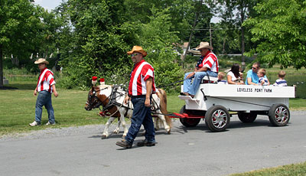
Glenn Loveless and his miniature horses are one of several modes of transportation at Celebrate Commemorate. Photo by Darlene Duprey

FOR IMMEDIATE RELEASE

WATERLOO – Getting around Waterloo during Celebrate Commemorate weekend is part of the fun. Visitors can go by bus, by boat, by horse and wagon and on foot.

Donald Eichenhofer, the “Transportation Czar,” has arranged a schedule of arrivals and departures that rivals Grand Central Station’s.

New this year will be a free shuttle bus service throughout the village, complements of the Seeneca Falls School District. The bus will make stops at the American Civil War Memorial, the Living History village on Oak Island, the National Memorial Day Museum and Lafayette Park as it takes visitors to the various activities. Bus stops will be marked at each site.

The popular horse and wagon rides through the village again will be offered by Carl and Dot Blood of Hillbilly Acres. Families may take the hour-long narrated historical tour of the village on Saturday and Sunday, May 26 and 27 between 12:15 and 3:15. Tours board on Memorial Day Place at the northeast end of Lafayette Park. Cost is $2 per person.

A half-hour short ride through the village also is available on Saturday and Sunday from noon to 3:30. The cost is $1 per person for adults and children in grade 6 and older; children in grades 5 and younger ride for free. Tickets will be available at the booth
on Memorial Day Place, on the northeast corner of Lafayette Park.

Walking tour brochures are available at the village office or at the information booth at southeast corner of the park. Visitors may stroll through the village at their leisure. Sites mentioned in the brochure are identified by historical markers.

Boat rides again will be offered by Bob Stivers’ Finger Lakes Water Adventures. The 30-passenger Liberty tour boat will leave from Oak Island for a one-hour cruise on the Cayuga-Seneca Canal. The cruise, which will go through Lock 4 and east on the canal, is not narrated. The boat is covered and operates rain or shine at 10 a.m., 12 noon, and 2 and 4 p.m. on Saturday and Sunday. Cost is $12 per person for adults and $8 per child age 12 and younger.

Tours are on a first come, first served basis. Group tours may be reserved by calling 315-789-5520.

Glenn Loveless will bring his charming miniature horses and wagons to Oak Island where children, accompanied by their parents and grandparents can take a ride on the paved driveway. The wagon seats about 10 people. The ride will depart near the boat launching area of the island.

Rides will be given between noon and 4 p.m. Saturday and Sunday. Cost is $1 for passengers age 1 and older. Tickets will be available at Oak Island.

The 13th annual Celebrate Commemorate event will be held May 25-27 in Waterloo, the Birthplace of Memorial Day. For more information about the events, go to www.waterloony.com.

The 146th consecutive commemoration of Memorial Day will be on Wednesday, May 30. It will include prayer services, and the official Memorial Day parade at 6 pm coordinated by the American Legion and VFW.

#30

